**Case 2: Volatility Models**

**Step 1 Visualize Data**

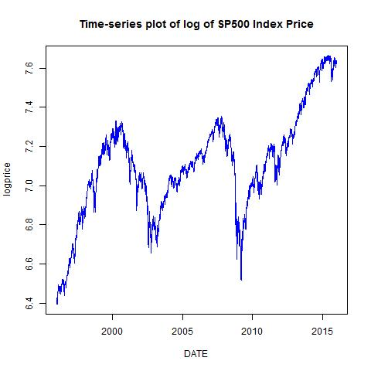

This time-series plot is for natural log of the S&P 500 index price. The Y-axis shows the logarithm of daily S&P 500 index price ranging from 6.4% to more than 7.6%. The X-axis displays the time period, from 1996 January to 2015 December. According to the graph,the index tooks two sharp downturn period in 2000-2003 and 2008 which might due to recession of the markets. Recall during 2001-2002, it was a large bear market due the internet bubble bursting, and Financial Crisis Happened in 2008-2009 with a crisis in the subprime mortgage market in the United States. By doing eyes examination, the graph of data series is a non-stationary data in the mean. In order to perform analysis all data must be transformed to stationary form, then some form of trend removal is required in this performance.

**Step 2.1 Dickey Fuller Test**

We conducted the test for your data series. We ran a DF test in order to see if our data either stationary or non-stationary. We set our K=0.

In our hypothesis we assumed in two senario:

The null of hypothesis H0: The logarithm of S&P 500 has unit root

The alternative of hypothesis H1: The logarithm of S&P 500 has no unit root

**Decision Rules:** reject if P-Value is less than 0

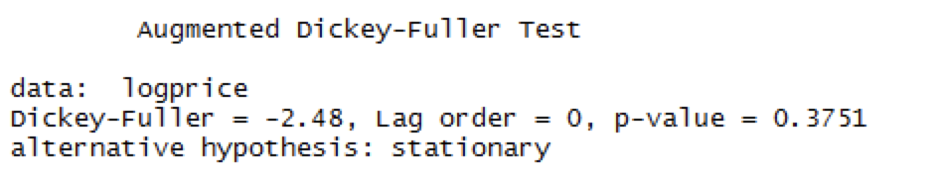

**Conclusion:** after ran the testing in R program, we found P-value is 0.3751, which higher than 0. This concluded that our data series has unit root.

**Step 2.2 Augmented Dickey Fuller Test**

The unit root tests in step 2.1 above valid are only if the time series of logarithm of S&P 500 price is well characterized by an AR(1) with white noise errors. However, with our data series is more complicated dynamic structure than just a simple AR(1) model. Therefore, we perform the augmented DF test on log of the S&P 500 stock index price. We tried a wider window where K= 17

We set the null hypothesis and its alternative where:

The null of hypothesis H0: φ = 1. Log of the S&P 500 stock index price is difference stationary

The alternative of hypothesis H1:φ < 1. Log of the S&P 500 stock index price is trend stationary

**Decision rule:** reject if P-value < 0

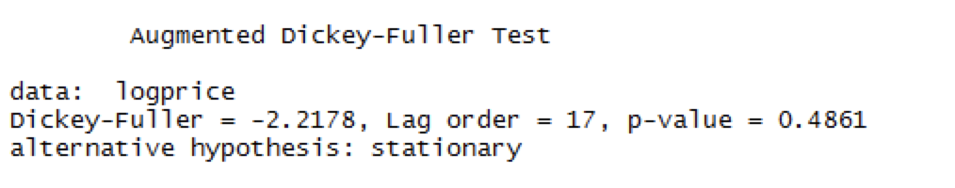

**Conclusion:** We found P-value = 0.4861. This show pretty clearly that after about 17 lags, the ADF statistic fails to reject the null hypothesis of a unit root. The appearance of periodicity in our data series indicates that the seasonality of the series has some impact of the value of the augmented DF test.

**Step 3.0 Time-Series Plot for the Market Stock Returns**  
 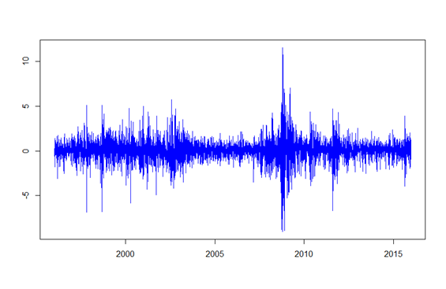  
This time-series plot demonstrates how S& P500 index returns performed as time changed. The Y-axis shows the daily S & P 500 returns, ranging from -10% to more than 12%. The X-axis displays the time period, from 1996 January to 2015 December. It could be easily found that the number of returns are quite persistent, fluctuating around 0. But we still can find the extreme numbers appeared in October, 2008, which is very interesting. The maximum of index return appeared on October 13th while the minimum value followed two days later. It happened probably because on Oct 13, 2008, HM Treasury infused £37 billion of new capital-bailout into Royal Bank of Scotland Group Plc, Lloyds TSB and HBOS Plc, to avert a financial sector collapse, which motivated the whole market. However, the higher market return may also accelerated the speed that the stock holders sold out their shares, which probably caused the collapse on Oct 15th.

**Step 3.1 Estimate an AR(p) Model**  
We fit an AR(p) model to the return series (the S&P 500 stock returns).   
**Estimated equation:**



**Results:**  
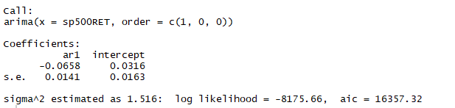

The result when we call the model in R shows the sigma^2 estimated is 1.516, which means the estimate of the variance of the process errors is 1.516. The maximized log-likelihood is -8175.66. Under this condition, φ1 in our estimated equation equals -0.0658 and µ equals 0.0316. And the AIC in our equation values 16357.32.  
  
Then we set p = 13 to the same model.   
Estimated equation:   
 

**Results:**  
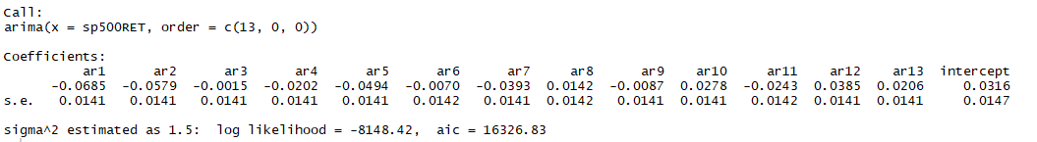

The result when we call the model in R shows the sigma^2 is 1.5, which means the estimate of the variance of the process errors is 1.5. The maximized log-likelihood in this equation is -8148.42. The φ1 to φ13 equal to -0.0685, -0.0579 , -0.0015, -0.0202, -0.0494, -0.0070, -0.0393, 0.0142, -0.0087, 0.0278, -0.0243, 0.0385, and 0.0206, while µ equals 0.316. Also, the AIC equals 16326.83.  
  
When we compare these two equations, we can find there is a little bit increase on the values of maximized log-likelihood. It means the second equation fit our dataset better. And when we compare the AIC values of these two models, the second one has a lower AIC value. It helps us to understand the parameters in the second equation.

**Step 3.2 Estimate multiple AR(p) Models**Then we tried to estimate thirteen AR(p) models with p=1,2,...13. The following table shows the value of sigma^2, log likelihood and AIC under different conditions.

|  |  |  |  |  |
| --- | --- | --- | --- | --- |
| Parameters | | sigma^2 | log likelihood | AIC |
| ar1 |  | 1.516 | -8175.66 | 16357.32 |
| ar1 | ar2 | 1.512 | -8168.37 | 16344.74 |
| ar1 | ar3 | 1.512 | -8168.37 | 16346.74 |
| ar1 | ar4 | 1.511 | -8167.81 | 16347.61 |
| ar1 | ar5 | 1.508 | -8161.71 | 16337.42 |
| ar1 | ar6 | 1.508 | -8161.63 | 16339.3 |
| ar1 | ar7 | 1.505 | -8157.39 | 16332.79 |
| ar1 | ar8 | 1.505 | -8157.06 | 16334.11 |
| ar1 | ar9 | 1.505 | -8156.83 | 16335.66 |
| ar1 | ar10 | 1.504 | -8154.91 | 16333.82 |
| ar1 | ar11 | 1.502 | -8152.93 | 16331.86 |
| ar1 | ar12 | 1.5 | -8149.48 | 16326.96 |
| ar1 | ar13 | 1.5 | -8148.42 | 16326.83 |

**Step 3.3 Select a model that minimizes AIC** 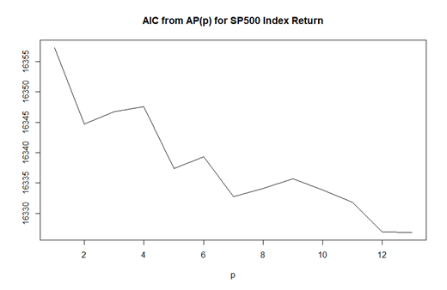  
From the above chart, we could find that when p=13, the value of AIC will be the lowest. To follow this baseline, we will select the AR (13) as the best model.

**Step 3.4 Select a model that minimizes BIC**   
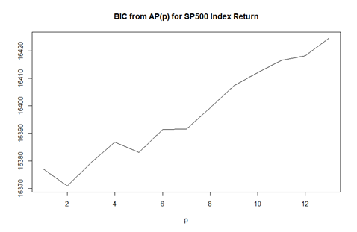

From the above chart, we could find that when p=2, the value of BIC will be the lowest. To follow this baseline, we will select the AR (2) as the best model.

In that case, we have to decide which one is better between AR (2) and AR (13). According to the case 2, BIC criterion shows that xt has AR structure p(optimal)= p(bic). AIC criterion shows that xt has AR structure p(optimal)= p(aic). So we will use BIC to decide which model is better as BIC penalizes the number of parameters much more than aic when sample size is large. And also, treat ꞓ as a serially uncorrelated shock series.

|  |  |  |
| --- | --- | --- |
|  | AR_AIC | AR_BIC |
| 1 | 16357.32 | 16376.89 |
| 2 | 16344.74 | 16370.83 |
| 3 | 16346.74 | 16379.35 |
| 4 | 16347.61 | 16386.74 |
| 5 | 16337.42 | 16383.07 |
| 6 | 16339.3 | 16391.47 |
| 7 | 16332.79 | 16391.49 |
| 8 | 16334.11 | 16399.34 |
| 9 | 16335.66 | 16407.41 |
| 10 | 16333.82 | 16412.09 |
| 11 | 16331.86 | 16416.65 |
| 12 | 16326.96 | 16418.27 |
| 13 | 16326.83 | 16424.66 |

**Step 4.1 Estimate an MA (q) Model**

We fit an MA (p) model to the return series (the S& P 500 stock returns).

Estimated equation when q = 1:



**Results:**

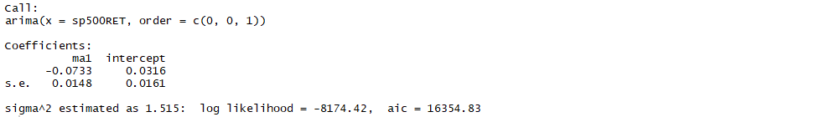

The result when we call the model in R shows the sigma^2 is 1.515, which means the estimate of the variance of the process errors is 1.515. The maximized log-likelihood is -8174.42, which means the estimated equation fit our dataset well. Under this condition, coefficients in our estimated equation equals -0.0733, and µ equals 0.0316. And the AIC in our equation values 16354.83.

Then we set q =2 to the same model.

Estimated equation when q=2:



**Results** 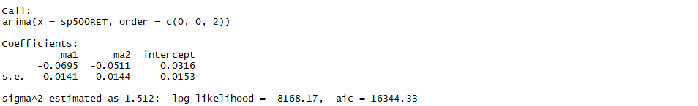

The result when we call the model in R shows the sigma^2 is 1.512, which means the estimate of the variance of the process errors is 1.512. The maximized log-likelihood in this equation is -8168.17. The φ1 to φ2 equal to -0.0695 and -0.0511, while µ equals 0.316. Also, the AIC equals 16344.33.

When we compare these two equations, we can find there is a little bit increase on the values of maximized log-likelihood. It means the second equation fit our dataset better. And when we compare the AIC values of these two models, the second one has a lower AIC value. It helps us to understand the parameters in the second equation.

**Step 4.2 Estimate an ARMA (p, q) Model**

In the next step, we are going to explore the ARMA (p,q) Model.

Estimated ARMA Equation when p=1, q=1:



**Results:**

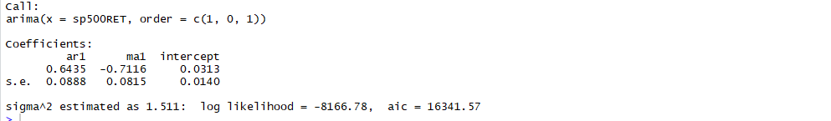

The result when we call the model in R shows the sigma^2 is 1.511, which means the estimate of the variance of the process errors is 1.511. The maximized log-likelihood is -8166.78, which means the estimated equation fit our dataset well. Under this condition, coefficient of ar1 in our estimated equation equals -0.0733, coefficient of ma1 equals -0.7116, and µ equals 0.0313. And the AIC in our equation values 16341.57.

Estimated ARMA (p, q) Equation when p = 0, q = 0 p = 0, q = 1 p = 0, q = 2 p = 1, q = 0 p = 1, q = 1 p = 1, q = 2 p = 2, q = 0 p = 2, q = 1 p = 2, q = 2:



|  |  |  |  |
| --- | --- | --- | --- |
| Parameters | sigma^2 | log likelihood | AIC |
|  | 1.523 | -8186.56 | 16377.11 |
| ma1 | 1.515 | -8174.42 | 16354.83 |
| ma1, ma2 | 1.512 | -8168.17 | 16344.33 |
| ar1 | 1.516 | -8175.66 | 16357.32 |
| ar1, ma1 | 1.511 | -8166.78 | 16341.57 |
| ar1, ma1, ma2 | 1.512 | -8168.16 | 16346.33 |
| ar1, ar2 | 1.512 | -8168.37 | 16344.74 |
| ar1, ar2, ma1 | 1.512 | -8168.37 | 16346.74 |
| ar1, ar2, ma1, ma2 | 1.51 | -8164.96 | 16341.92 |

**Step 4.3 Select a model that minimizes AIC**

Then we create a table for AIC values. Three rows list different AR orders and three columns list different MA orders.

[0] [1] [2]

[0] 16377.11 16354.83 16344.33

[1] 16357.32 16341.57 16346.33

[2] 16344.74 16346.74 16341.92

From the above table, we can find that when p =1, q=1, the value of AIC is the lowest. In that case, we will select the model ARMA (1,1) as the best one among them.

**Step 4.4 Select a model that minimizes BIC**

Then we create a table for BIC values. Three rows list different AR orders and three columns list different MA orders.

[0] [1] [2]

[0] 16390.16 16374.40 16370.42

[1] 16376.89 16367.66 16378.94

[2] 16370.83 16379.35 16381.05

From the above table, we can find that when p =1, q=1, the value of BIC is the lowest. In that case, we will select the model ARMA (1, 1) as the best one among them.

To summary the step 4.3 and step 4.4, we will select ARMA (1, 1) as the optimal one.

**Step 4.5 ARMA (1, 1) Diagnosis Test**

A.(1)

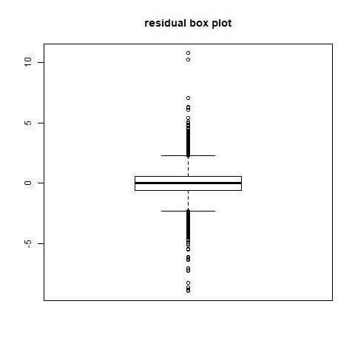

According to the box plot, we found that the median of disturbances term εt close to zero (0.051740), and the shape of the graph is roughly symmetrical, which means it could be a normal distribution.

(2)

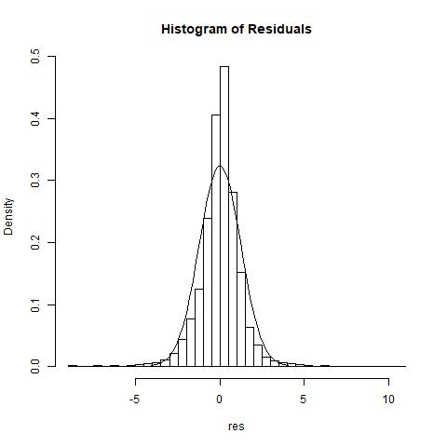

In the “Histogram of the Residuals”, the Y-axis represents the probability of the residuals in each bin and the X-axis represents residual itself. The curve is the shape of normal distribution with the residuals’ mean and standard deviation. According to the graph, we can see that the distribution of residuals is more peak than that of normal distribution and has a fatter tail. Except the peak of the distribution, the rest of shape is along with the standard normal distribution.

(3)

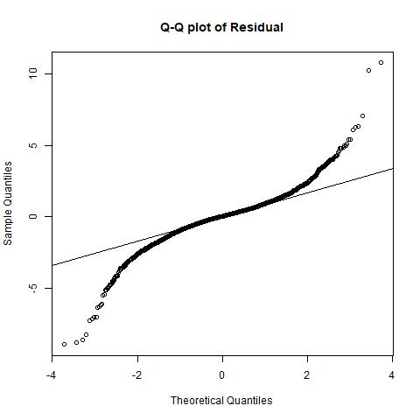

In the Q-Q plot of residuals, the horizon axis shows the theoretical quantiles values generated from the normal distribution while the vertical axis shows the quantile of residuals generated from previous linear model. And the line crosses the dots means where the most of dots are if the data were normally distributed. From this plot, we learn that most dots are close to the theoretical quantiles line. The rest dots also draw an upward curve on the higher end and a downward curve on the lower end. In this case, we can assume that the residuals are not follow a normal distribution.

(4)

For the Jarque-Bera test for the disturbances term:

H0: The residuals of ARMA(1,1) comes from normal distribution.

H1: The residuals of ARMA(1,1) doesn’t come from normal distribution.

Decision Rules: Reject if p-value < 5%

Conclusion: After running the codes in R, we found the p- value <2.2e-16, which is obviously lower than 5%. In that case, we decided to reject the hypothesis, which means the residuals of ARMA(1,1) doesn’t come from normal distribution.

(5)

For the lilliefors test for the disturbances term:

H0: The residuals of ARMA(1,1) comes from normal distribution.

H1: The residuals of ARMA(1,1) doesn’t come from normal distribution.

Decision Rules: Reject if p-value < 5%

Conclusion: After running the codes in R, we found the p - value <2.2e-16, which is obviously lower than 5%. In that case, we decided to reject the hypothesis, which means the residuals of ARMA(1,1) does not come from normal distribution.

B.(1)

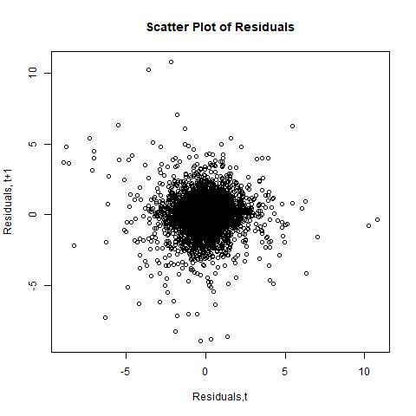

This scatter plot in which the values of two variables are plotted along two axes, the pattern of the resulting points revealing any correlation present. In other words, a scatter plot can show if there is any connection between the two variables. Base on the graph, the dots are mostly lie on the center and close to each other, which means there could be an autocorrelation between residuals.

(2)

For the Ljung-Box Q-test test for the disturbances term:

H0: The residuals of ARMA(1,1) exhibits no autocorrelation for lags=5.

H1: The residuals of ARMA(1,1) exhibits autocorrelation for lags=5.

Decision Rules: Reject if p-value < 5%

Conclusion: After running the codes in R, we found the p - value = 0.03558, which is lower than 5%. In that case, we decided to reject the hypothesis, which means the residuals of ARMA(1,1) exhibits autocorrelation for lags=5. In addition, the p-value under other cases(lags=10,15,20 respectively) are smaller than 0.05.

C.

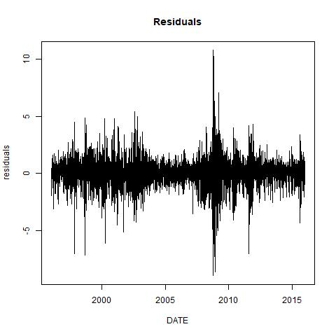

The y-axis represents the residuals and the x-axis represents date. According to the graph, the residuals didn’t have a constant variance, which means it shows heteroscedasticity. Therefore, ARMA(1,1) model is highly inconsistent in accuracy when it predicts extreme values and the results of that regression should not be trusted.

**Step 4.6 ARMA(1,1) Predicted Value**

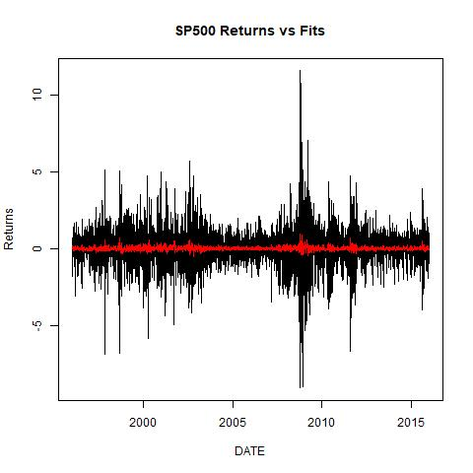

In this graph, the y-axis represents the returns in percentage and the x-axis represents date. And black line represents S& P500 index returns while red line represents fitted value of ARMA(1,1) model. As shown above, the model is relatively accurate when it predicts low values (return that close to zero), but highly inconsistent in accuracy when it predicts extreme values (large gain or loss in stocks). Overall, the result of the model cannot be trusted.

|  |  |  |  |  |  |  |  |
| --- | --- | --- | --- | --- | --- | --- | --- |
|  | ME | RMSE | MAE | MPE | MAPE | MASE | ACF1 |
| Training Set | 0.000353 | 1.22911 | 0.840988 | -Inf | Inf | 0.67287 | -0.002973 |

The table basically is a range of summary measures of the forecast accuracy. Firstly, Mean Error of the training set is 0.000353, which is a relatively small number. Root Mean Squared Error, Mean Absolute Error and Mean Absolute Scaled Error don’t have a specific benchmark, so it is difficult to compare. However, Mean Percentage Error and Mean Absolute Percentage Error are –Inf and Inf respectively, which means the error of a single estimation is huge

**Step 4.7 Training and test sets**

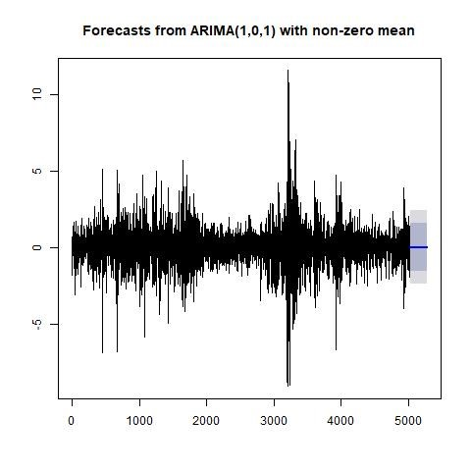

In this graph, horizontal axis shows the number of days while the vertical axis shows the S&P 500 return in percentage. As shown above, the forecast values (blue line) in case 1 are close to zero (around 0.03), the 80% confidence interval (blue area) is [-1.55, 1.61] and 95% confidence interval (grey area) is [-2.38, 2.44]. Basically, the model can predict a reasonable number of the daily return but not a precise one.

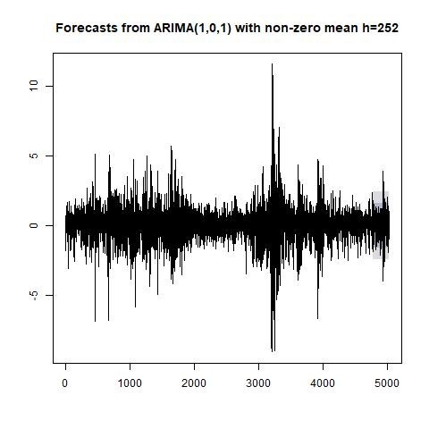

Figure 2, same as previous figure, horizon axis shows the number of days while the vertical axis shows the S&P 500 return in percentage. In this case, most of the test set data fall in 80% confidence interval of the predicted values, but it is obvious that some actual values exceed 95% confidence interval of the predicted values, which proves that the ARMA(1,1) model cannot predict extreme conditions again.

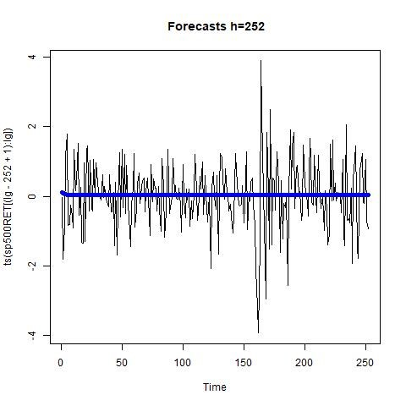

Figure 3 is actually a closer look at the last part of figure 2, horizon axis shows the number of days (last 252 days) while the vertical axis shows the S&P 500 return in last 252 days of the data set. As we can see, the real data is noisy and predicted values are persistent. The return looks randomly moving up and down, but the model keep the prediction constant.

|  |  |  |  |  |  |  |  |
| --- | --- | --- | --- | --- | --- | --- | --- |
|  | ME | RMSE | MAE | MPE | MAPE | MASE | ACF1 |
| Training Set | -0.00031 | 1.24123 | 0.84759 | -Inf | Inf | 0.67197 | -0.00395 |
| Test Set | -0.03237 | 0.974985 | 0.721230 | 104.6463 | 113.5124 | 0.571789 | NA |

The same as the previous table it shows a range of summary measures of the forecast accuracy. The ME of test set is obviously larger than that of training set, it might cause by the size of the sample. On the other hand, the MPE and MAPE of test set are both smaller because the extreme values in this time period is smaller.

**Step 5.1 Autocorrelation plot for the squared residuals**

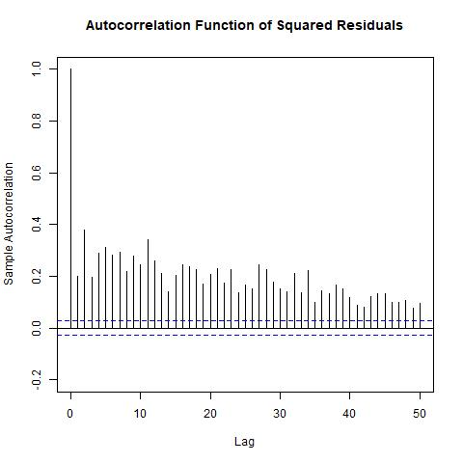

From the plot we see that we can strongly reject that the squared disturbance term are serially uncorrelated (the auto-correlations are all outside the confidence band). Therefore we strongly reject that disturbance terms t are independent. It also suggests that an MA(q) (q > 50) or AR(p) (p > 0) or ARMA(p, q) (p > 0 and q > 0) can capture the long memory dynamic of the squared disturbance term .

**Step 5.2 Partial autocorrelation plot of the squared residuals**

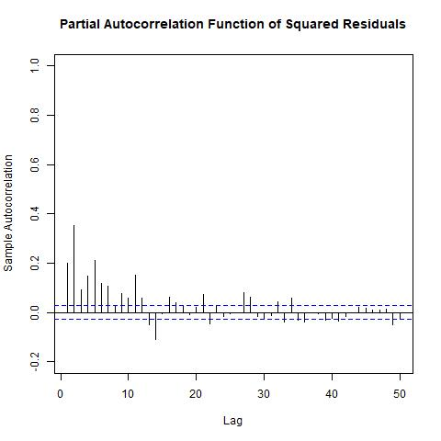

From the plot we see that we can strongly reject that the squared disturbance term are serially uncorrelated (the auto-correlations are all outside the confidence band). Therefore we strongly reject that disturbance terms t are independent. It also suggests that an AR(p) (p = 35) or MA(q) (q > 0) or ARMA(p, q)(p > 0 and q > 0) can capture the long memory dynamic of the squared disturbance term . Taking the ACF and PACF plots together, in order to find a suitable model with fewer number of parameters, we suggest that both AR terms and MA terms are necessary.

Step 5.3 Time-Varying Volatility

Suppose the innovations are generated as =,where is an IID process with mean 0 and variance 1. Thus, E( ) =0 for all lags hand the innovations are uncorrelated. Let denote the history of the process available at time t. The conditional variance is Var( |)=Var()=E(|)= Thus, conditional heteroscedasticity in the variance process is equivalent to autocorrelation in the squared innovation process.

**Step 5.4 Engle test**

The idea of Engle test is simple: fit the AR(p) model to squared shocks and test the hypothesis that all coefficients are jointly zero.

We set the null hypothesis and its alternative where:

Ha : 2 t = α0 + α1 2 t−1 + ... + αm 2 t−m + ut

H0 : α1 = ... = αm = 0

**Decision rule:** reject if P-value < 0

**Conclusion:** after we do the summary of Model, we can see that the p-value is < 2.2e-16, which is extremely close to 0. Hence, we reject the null of hypothesis.

**Step 5.5 Ljung-Box Q-Test**

The Ljung-Box Q-test is a portmanteau test that assesses the null hypothesis that a series of residuals exhibits no autocorrelation for a fixed number of lags m, against the alternative that some autocorrelation coefficient. We are checking our testing in step 5.4 by using LLjung-Box Q-Test.

We set the null of hypothesis and its alternative where:

Ho: the data are random

Ha: the data are not random

**Decision:** reject if P-value is smaller than 0.05 in oder to confirm the null hypothesis of residuals independence.

**Conclusion:**

In our tesing on Ljung-Box Q test it showed p-value < 2.2e-16, which is very close to 0. Therefore, we reject the null of the hypothesis.

**Step 6.1 GRACH family**

Estimation:

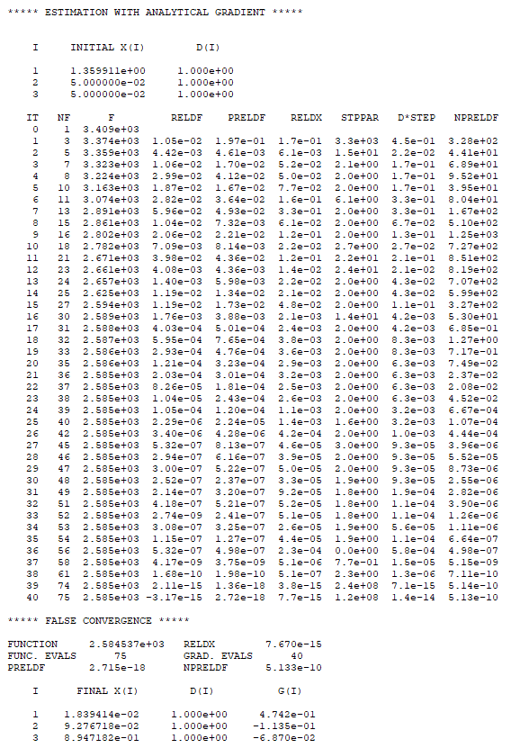

**Estimated Equation:**

=0.01839+0.09277+0.89472

Interpreted the estimated parameter

In the equation, we see all the coefficient of each parameter is positive, which mean our GARCH models is not subject to volatility.

Discuss the p-value

p-value is < 2.2e-16

As we could see in our P-value is 2.2e-16 which very close to 0. We concluded that there is no volatility in our GARCH model.

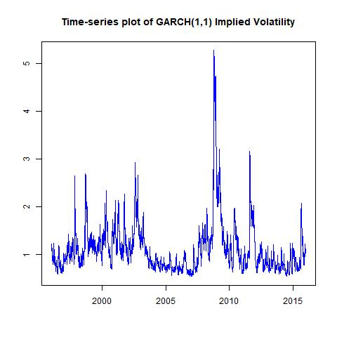

This time-series plot is for GRACH(1,1) implied volatility. The Y-axis shows the percentage of volatility. The X-axis displays the time period, from 1996 to 2015. According to the graph, the trend of residuals shows there are two uptrend period in 2000-2003 and 2008 which might due to recession of the markets. Recall during 2001-2002, it was a large bear market due the internet bubble bursting, and Financial Crisis Happened in 2008-2009 with a crisis in the subprime mortgage market in the United States.

**Step 6.2 ARMA (1,1)+ GARCH (1,1)**

To estimate an ARMA(1,1) for return process xt together with GARCH(1,1) model for residuals t = σtηt from the ARMA(1,1) model, we built following equations:

Estimated Equations:

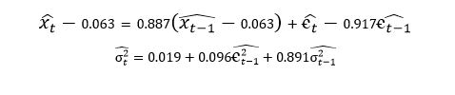

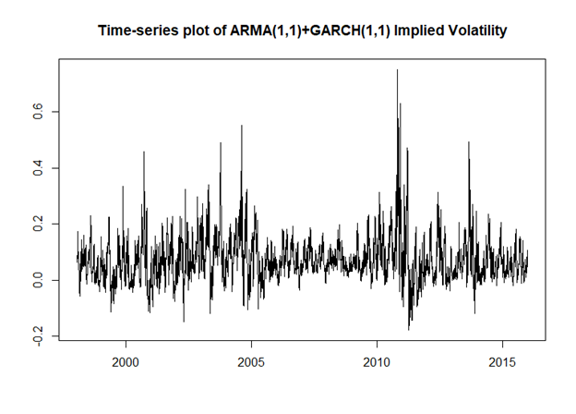

This time-series plot shows the change of the volatility process σt as time going. The x-axis displayed the date from beginning of 1996 to the end of 2015 and the y-axis shows the values of volatility process, ranging from -0.2 to 0.7. It can be seen that the values of σt fluctuates around 0. The maximum value appears in 2012.

**Results:**

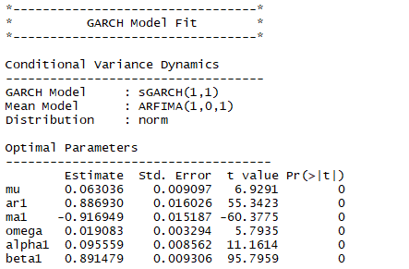

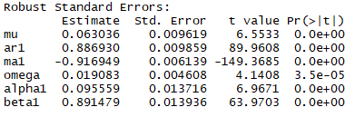

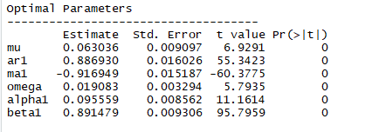

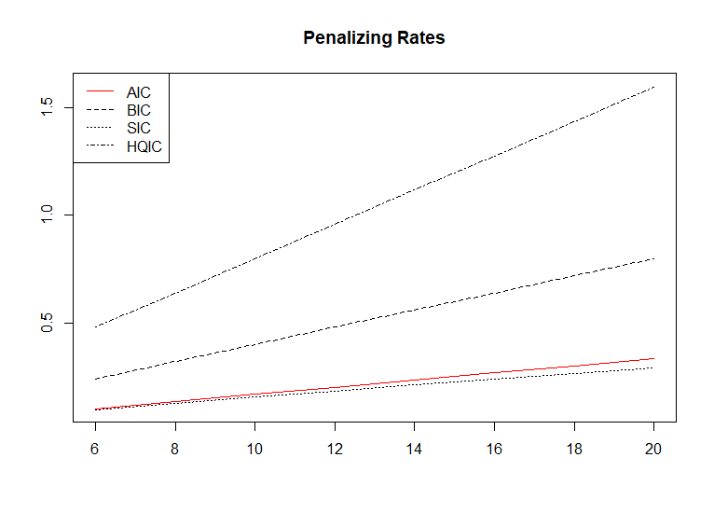

The infor criteria method on a fitted or filtered object returns the Akaike (AIC), Bayesian(BIC), Shibata (SIC) and Hannan-Quinn (HQIC) information criteria to enable model selection by penalizing overfitting at different rates. We use a plot to demonstrate our understanding of different penalizing rates. In our plot, we see HQIC has the highest rate compares to other.

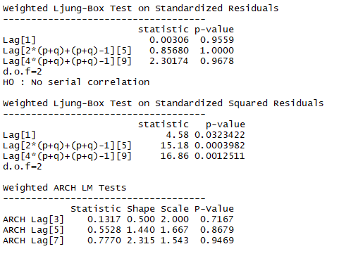

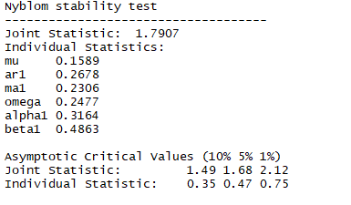

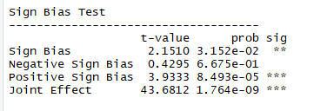

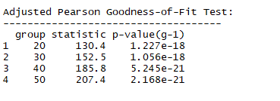

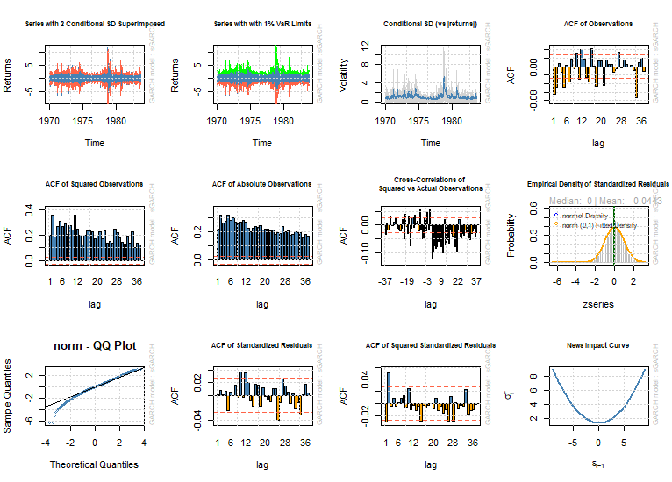

**Robust Standard Error:**

In our the robust standard errors are based on the method of White which produces asymptotically valid confidence intervals by calculating the covariance (V) of the parameters (θ) as:

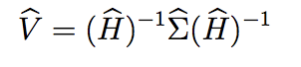

**Result:** in our result we do not find any significant differences between two sets of standard errors, then we could be confident in your results based on homoskedasticity**.**

The nymblom test calculates the parameter stability test of Nyblom (1989), as well as the joint test. Critical values against which to compare the results are displayed, but this is not available for the joint test in the case of more than 20 parameters. Nyblom (1989) derives the locally best invariant test as the Lagrange multiplier test. The hypotheses of interest are

Our hypothesis testing is:

Ha : Parameter is not constant over time ≡ structural change exists

H0 : Parameter is constant over time ≡ no structural change

**Decision:** reject if P-Value is less than 0

**Result & Conclusion:** we see in the nymblom test our P-Value is > 0 which obviously bigger than 0. Therefore, we do not reject the null of the hypothesis. Our conclusion we say our parameter is constant over time with no structural change.

**Step 6.3 ARMA(1,1)+ EGARCH (1,1)**

The exponential GARCH (EGARCH) model is a GARCH variant that models the logarithm of the conditional variance process. In addition to modeling the logarithm, the EGARCH model has additional leverage terms to capture asymmetry in volatility clustering.

**Estimated Equations**: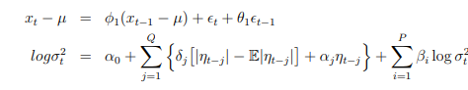

**Testing:** Ha : Parameter is not constant over time ≡ structural change

exists

H0 : Parameter is constant over time ≡ no structural change

**Result:**

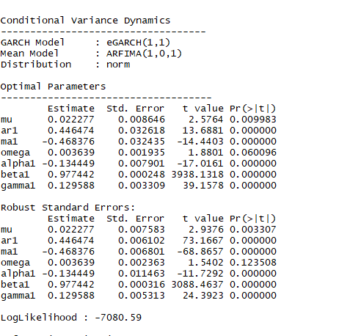

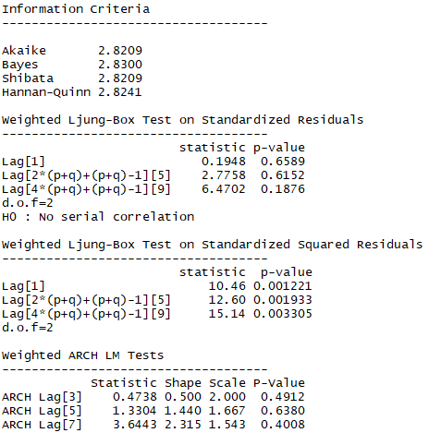

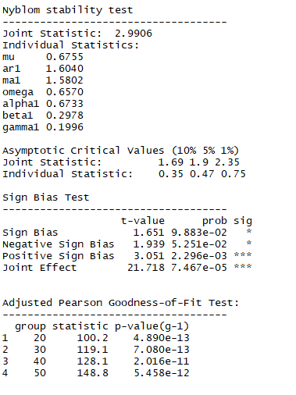

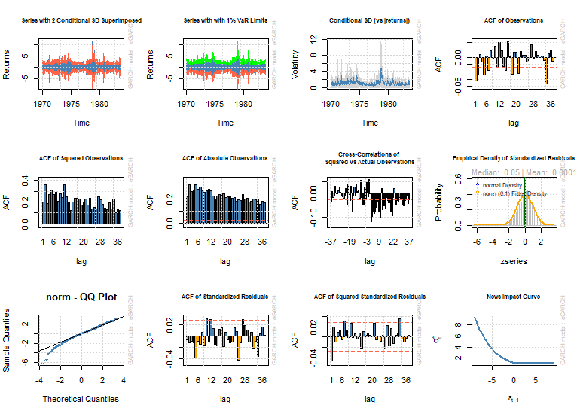

**Decision:** reject if variance is > 0

**Conclusion:** in our result under “Nyblom stability test” we see the variance of the testing is2.9906, which obviously bigger than 0. We concluded that Parameter is not constant over time which means structural change exists.

**Step 6.4 ARMA(1,1)+ GJR (1,1)**

The GJR model is a GARCH variant that includes leverage terms for modeling asymmetric volatility clustering. In the GJR formulation, large negative changes are more likely to be clustered than positive changes. The GJR model is named for Glosten, Jagannathan, and Runkle.

**Estimated Equations:**

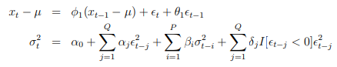

**Testing:** H0 : No serial correlation

Ha : has serial correlation

**Result:**

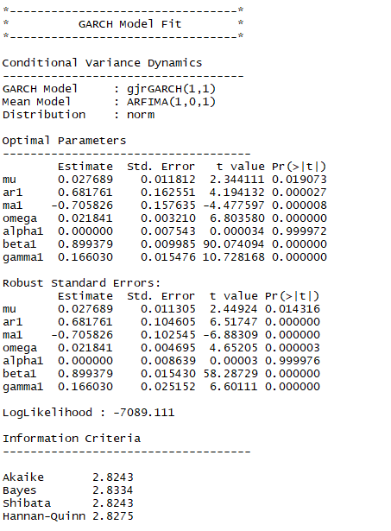

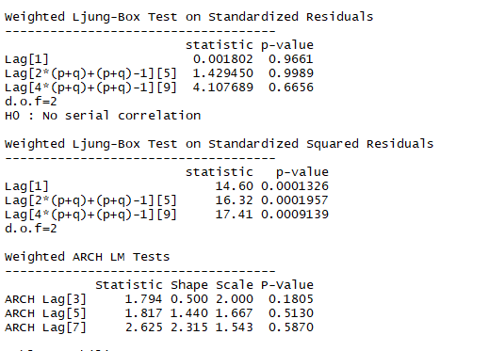

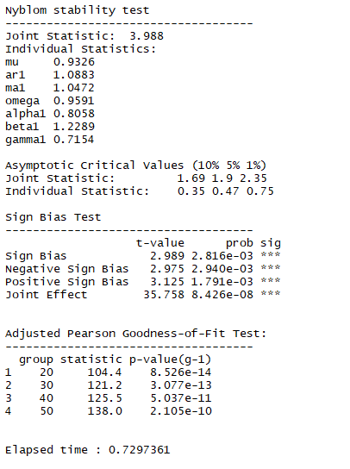

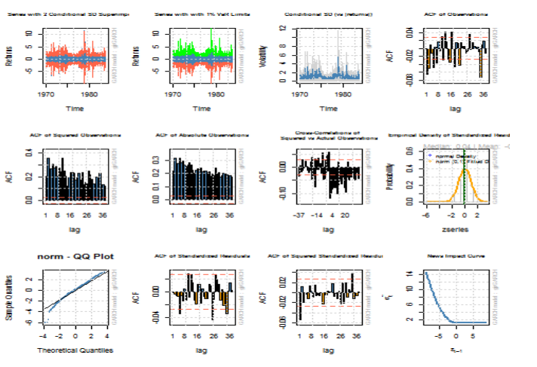

**Decision:** Reject if P-value < 0

**Conclusion:** in our result under “weight ARCH LM test” we see the P-value is >0. We concluded that our hypothesis has no series correlation.

**Step 7 Times-Series plot for Realized Volatility**

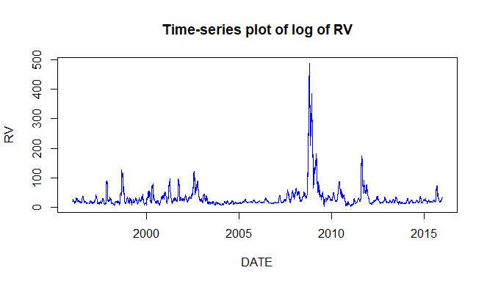

This time-series plot is return of realized volatility of the index. Realized volatility referred to as the historical volatility, this term usually used in the context of the derivatives while the implied volatility refers to the market's assessment of future volatility, the realized volatility measures what actually happened in the past. The measurement of the volatility depends on the particular situation. The Y-axis shows the percentage of volatility. The X-axis displays the time period, from 1996 to 2015. According to the graph, the return of realized volatility shows there is a sky rocking 2008 which might due to recession of the market where the financial crisis happened in 2008-2009 with a crisis in the subprime mortgage market in the United States.

**Step 8 Times-series plot of VIX**

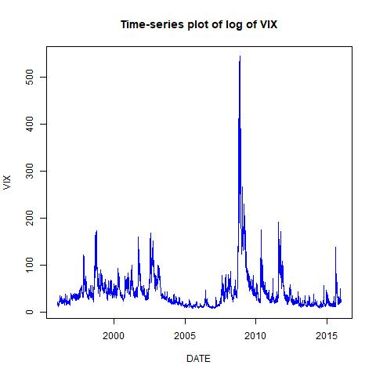

This time-series plot is return of future volatility index. VIX usually have an reserve direction to the bull market. VIX is predicted the future market volatile regarding to shock news either short-term event or long term event. For example, there are the federal raise interest rate, mid-term election, trade war agreement ect. In our case we see a huge sharp uptrend in 2008 where all the market indices get crashed. Second largest uptrend we can see it happened in 2011, it wasn’t a major event as there is a correction happened to the US stock market due to the fears of contagion of the European sovereign debt crisis to Spain and Italy, as well as concerns over France’s national credit rating. The Y-axis shows the percentage of volatility. The X-axis displays the time period, from 1996 to 2015.

**Step 9 Variance Risk Premium**

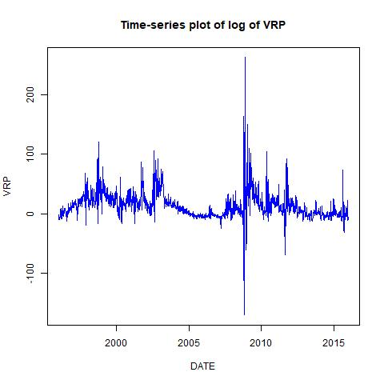

This time-series plot is return of variance risk premium index.The Y-axis shows the percentage return of VRP. The X-axis displays the time period, from 1996 to 2015. In our graph, it showed a negative sign on the Variance Risk Premium in 2008 indicates that variance buyers are willing to accept a negative average excess return to hedge away upward movements in stock market volatility. In other words, investors regard increases in market volatility as unfavorable shocks to the investment opportunity.